New Instructions for accessing the optional mock exam and compulsory homework
Because they were quite hidden in the getting started section of the anatomy and physiology e-course, I have decided to create a new unit called course completion documents, found at the bottom of the drop-down menu when you select Anatomy and Physiology in the tool bar.

1/Select course completion documents 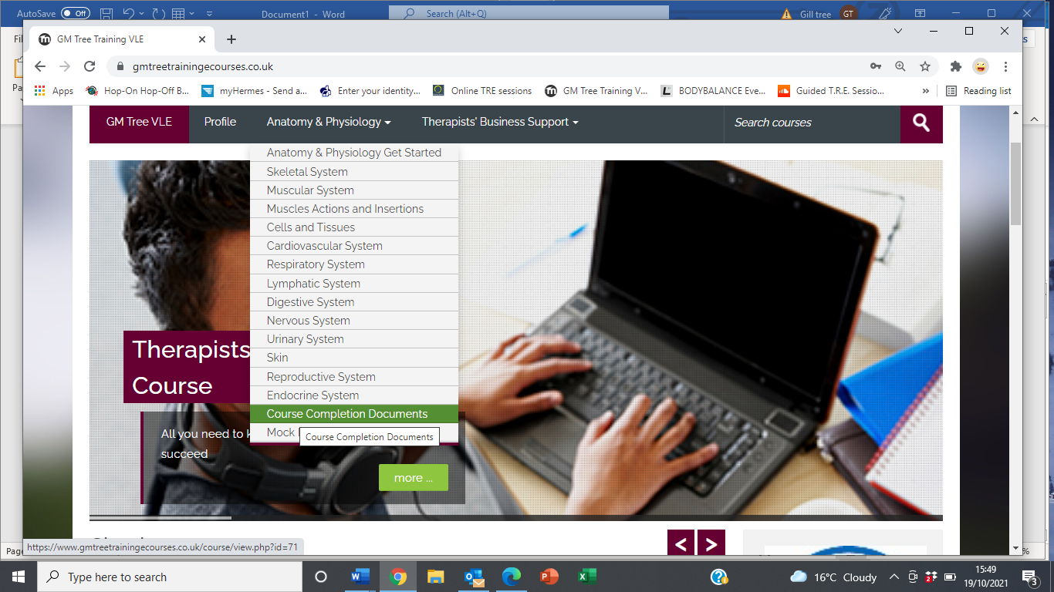

2/The homework and mock exam should automatically come up along with the compulsory evaluation form. If however they don’t -Select the enrol me green box in the bottom left-hand corner
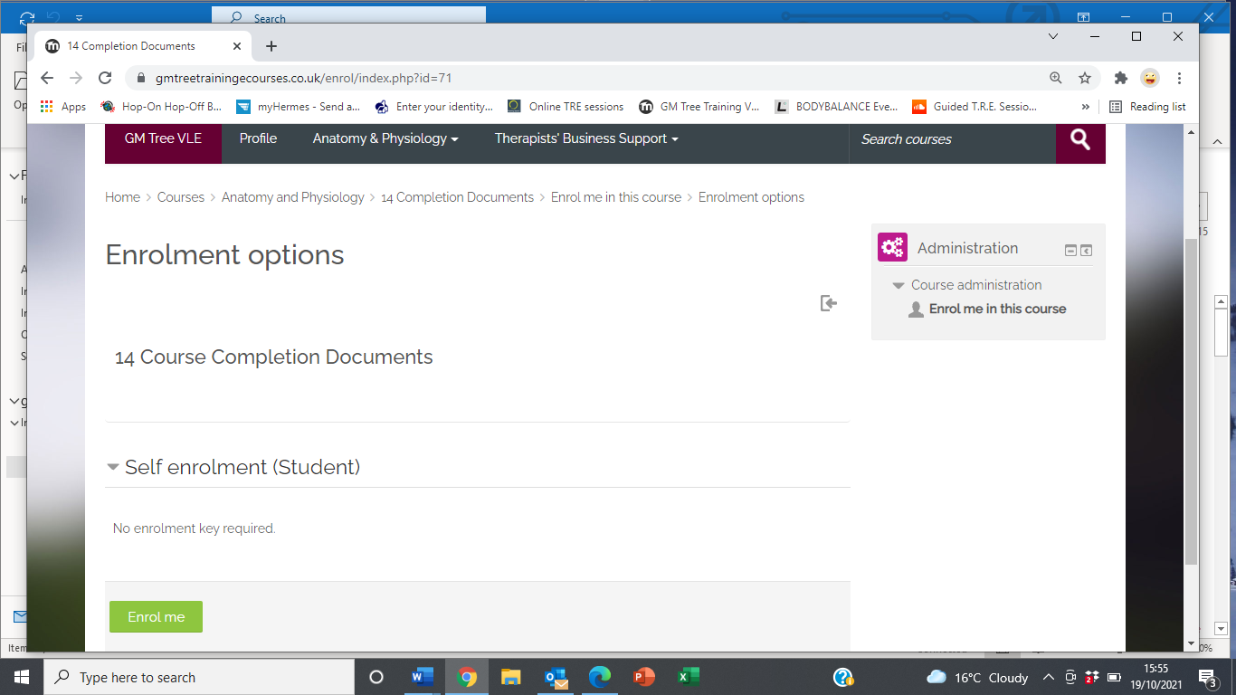
3/ Complete the compulsory evaluation form and the homework and mock exam will become available.
Call us if you have any issues or questions on 0203 553 1060.
Thank you

